NUNDU NEWS December 20, 2025
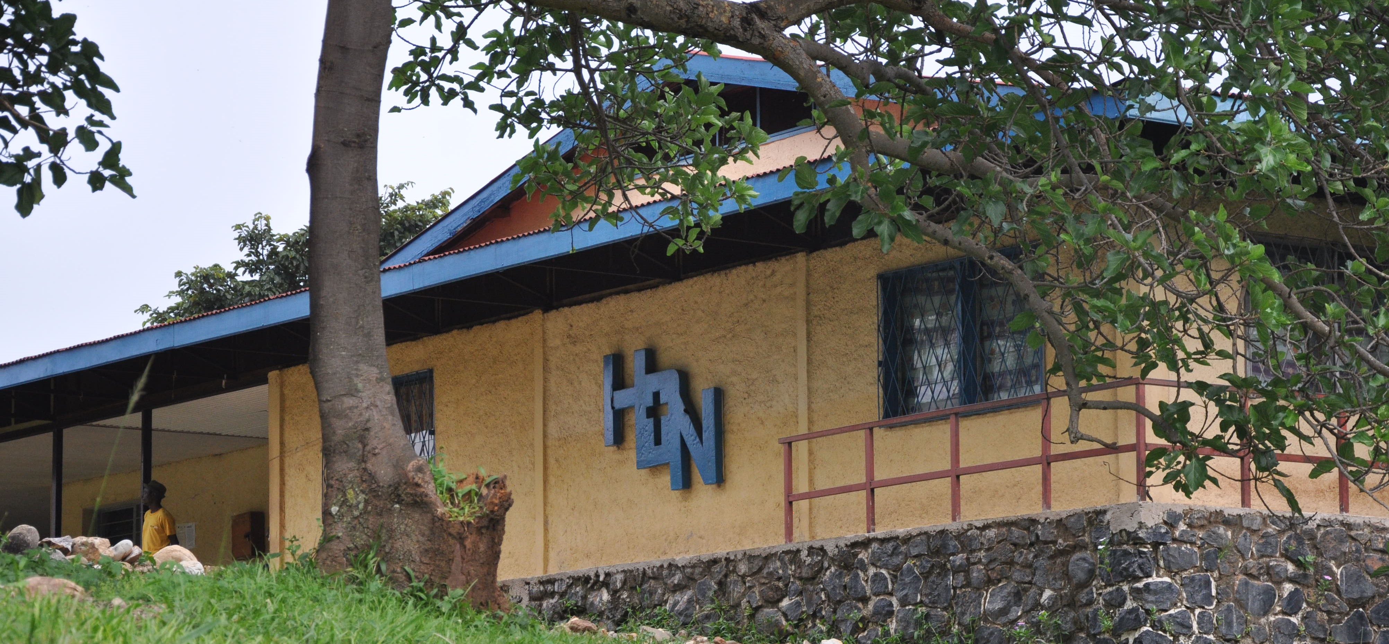
Christmas Blessings - Light in the Darkness
The people who walk in darkness
will see a great light.
For those who live in a land of deep darkness,
a light will shine. Isaiah 9:2 NLT

This Year 2025 in Review
This year began on an optimistic note as Dr. McGee joined Dr. ByaMungu at Nundu, forming an effective surgery team. More than 50 patients were seen, with an average of three major surgeries per day for two weeks. In all, 32 major surgeries were performed. However, as Dr. McGee was winding down his mission at the end of January, the M23 military took control of Goma, the provincial capital of North Kivu. By mid-February Bukavu, the provincial capital of South Kivu, had fallen. These major cities have been learning to live under a new normal.
In the face of this conflict and uncertain times, you stepped up with your prayers and financial support. The hospital staff remained committed to providing care for our population, offering hope and a future. Thanks to your generous giving, we have been able to provide $2000/m to purchase pharmaceutical and medical supplies. With this support the hospital paid off a $6000 debt to a pharmacy in Uvira, and by the end of March they were able to see the hospital pharmacy fully stocked. In addition, we have been able to encourage the hospital staff with salary supplements, which comes to more than $5,000/m.
In July, Dr. McGee returned to Nundu with a follow-up surgery team to find the hospital fully functional, even as the two major cities to the north, Goma and Bukavu, continued to be occupied. A sense of calm had returned. The team provided the hospital with a sense of hope and a light in the darkness. Free medical consultations were provided for 230 patients. Major surgeries were performed for 68 patients. A Gospel message was delivered daily in the morning chapel service.
During this time of conflict, the Nundu School of Nursing remained in session, with a short break in late February because of concerns about security. The construction of the classroom building was put on hold in February but resumed in September and has continued until … the fall of Uvira.
Yes, the M23 solidified their control of South Kivu by moving into Uvira the first week of December. This city is a strategic commercial and political center. Nundu Deaconess Hospital purchases medications, medical supplies, fuel, maintenance supplies, and building materials in this city of 700,000. This is an important transportation hub. To get to Burundi from Nundu you must pass through Uvira.
From day to day, we don’t know the outcome of this conflict, nor do we even know what the next day will bring. Even though there was fear that the M23 would advance south to Nundu, they have staged a strategic withdrawal. In the face of this uncertainty, we have hope. We have a mission of delivering compassionate healthcare, empowering communities, and building a sustainable healthcare system. The mission of Nundu Deaconess Hospital is to shine light in the darkness.
Your gifts have ensured that the hospital will continue to thrive. The hospital is supplied with pharmaceuticals and medical supplies. Hospital and school of nursing staff have been encouraged with salary supplements. Power from the solar plant keeps the lights on and powers medical equipment. The Nundu School of Nursing continues to train nurses and midwives who live out our mission.
Thank you for your support, needed more than ever. We will deliver, empower, and build; and if necessary, rebuild after this conflict is over. This mission sounds a lot like Judah’s call to rebuild after their Babylonian captivity and shine a light in the darkness.
Thank you for being a Champion for Congo.
Shalom, Tim Kratzer
Our Mission:
We champion equitable, holistic healthcare in rural Eastern Congo by:
- Delivering compassionate, trauma-informed treatment and healing.
- Empowering communities to take charge of their health and economic futures.
- Building a resilient and sustainable healthcare system for generations to come.
Our Vision:
Healthy, thriving, and resilient communities in Eastern Congo where every life is cherished and uplifted.

Champions4Congo
www.congohealth.org

